C:\Program Files\Microsoft Office\MEDIA\CAGCAT10\j0230876.wmfC:\Program Files\Microsoft Office\MEDIA\CAGCAT10\j0230876.wmfC:\Program Files\Microsoft Office\MEDIA\CAGCAT10\j0230876.wmfC:\Program Files\Microsoft Office\MEDIA\CAGCAT10\j0230876.wmfC:\Program Files\Microsoft Office\MEDIA\CAGCAT10\j0230876.wmfC:\Program Files\Microsoft Office\MEDIA\CAGCAT10\j0230876.wmfC:\Program Files\Microsoft Office\MEDIA\CAGCAT10\j0230876.wmfC:\Program Files\Microsoft Office\MEDIA\CAGCAT10\j0230876.wmf

Música d’ O Nosso Casamento

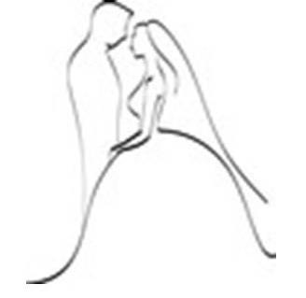

Bruna & João

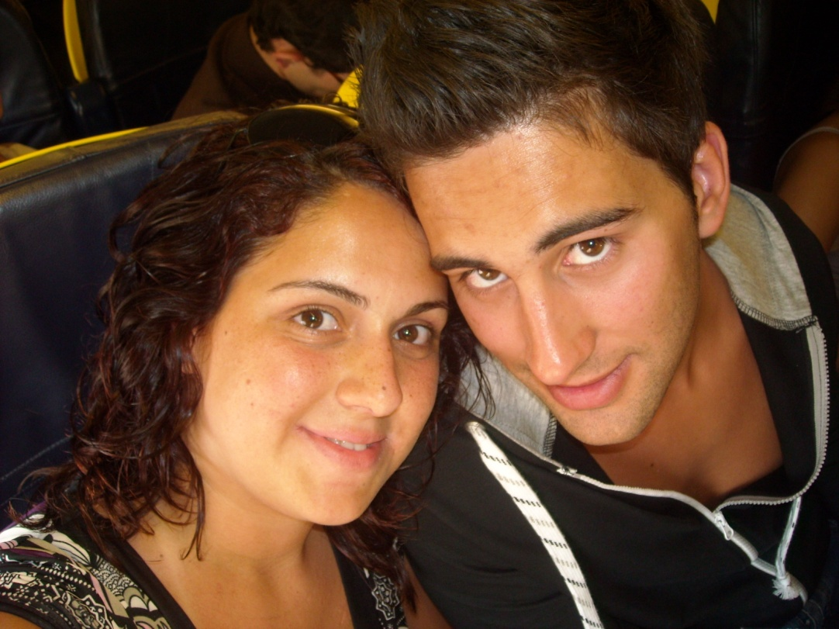

C:\Program Files\Microsoft Office\MEDIA\CAGCAT10\j0230876.wmfC:\Program Files\Microsoft Office\MEDIA\CAGCAT10\j0230876.wmfC:\Program Files\Microsoft Office\MEDIA\CAGCAT10\j0230876.wmfC:\Program Files\Microsoft Office\MEDIA\CAGCAT10\j0230876.wmfC:\Program Files\Microsoft Office\MEDIA\CAGCAT10\j0230876.wmfC:\Program Files\Microsoft Office\MEDIA\CAGCAT10\j0230876.wmfC:\Program Files\Microsoft Office\MEDIA\CAGCAT10\j0230876.wmfC:\Program Files\Microsoft Office\MEDIA\CAGCAT10\j0230876.wmf

Cerimónia

|  |  |  |
| --- | --- | --- |
|  | Nome da Música | Interprete |
| Preludio |  |  |
| Entrada |  |  |
| Cerimónia |  |  |
| Saída |  |  |

C:\Program Files\Microsoft Office\MEDIA\CAGCAT10\j0230876.wmfC:\Program Files\Microsoft Office\MEDIA\CAGCAT10\j0230876.wmfC:\Program Files\Microsoft Office\MEDIA\CAGCAT10\j0230876.wmfC:\Program Files\Microsoft Office\MEDIA\CAGCAT10\j0230876.wmfC:\Program Files\Microsoft Office\MEDIA\CAGCAT10\j0230876.wmfC:\Program Files\Microsoft Office\MEDIA\CAGCAT10\j0230876.wmfC:\Program Files\Microsoft Office\MEDIA\CAGCAT10\j0230876.wmf

C:\Program Files\Microsoft Office\MEDIA\CAGCAT10\j0230876.wmf

Recepção



|  |  |  |
| --- | --- | --- |
|  | Nome da Música | Interprete |
| Cocktail | |  |  |
| Entrada dos noivos na sala | |  |  |
| Almoço | |  |  |
| Primeira dança dos Noivos | |  |  |
| Abertura do Baile | |  |  |
| Baile | |  |  |
| Música para cortar o Bolo | |  |  |
| Outros Pedidos Especiais | |  |  |
| Última dança | |  |  |
| Lista do “não toquem isto” | |  |  |

C:\Program Files\Microsoft Office\MEDIA\CAGCAT10\j0230876.wmfC:\Program Files\Microsoft Office\MEDIA\CAGCAT10\j0230876.wmfC:\Program Files\Microsoft Office\MEDIA\CAGCAT10\j0230876.wmfC:\Program Files\Microsoft Office\MEDIA\CAGCAT10\j0230876.wmfC:\Program Files\Microsoft Office\MEDIA\CAGCAT10\j0230876.wmfC:\Program Files\Microsoft Office\MEDIA\CAGCAT10\j0230876.wmfC:\Program Files\Microsoft Office\MEDIA\CAGCAT10\j0230876.wmfC:\Program Files\Microsoft Office\MEDIA\CAGCAT10\j0230876.wmf