[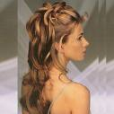](http://www.cadepaulinia.com/gerenciador/upload/conteudo/dica/pENTEADOS%20PARA%20NOIVAS%20II.jpg)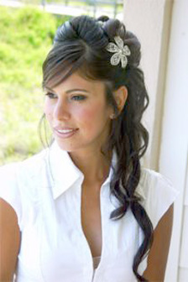[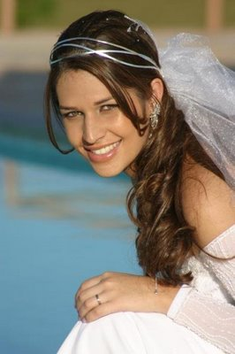](http://3.bp.blogspot.com/_Fi1-C_mm7Rc/Slgn72SNJkI/AAAAAAAADXI/9bC3wjHaqvg/s1600-h/9.jpg)

